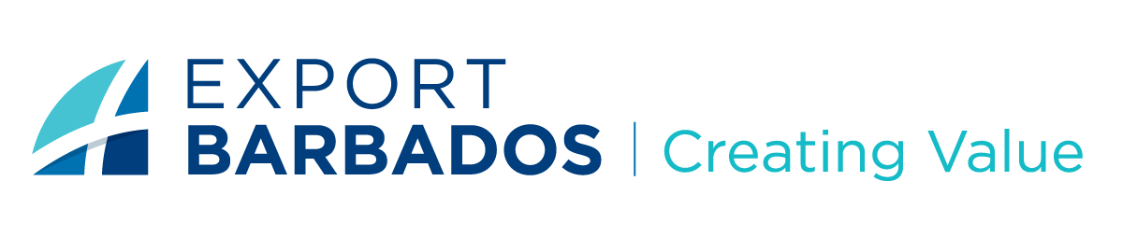
Barbados Investment and Development Corporation

REQUEST FOR PROPOSAL
PROVISION OF LEGAL SERVICES FOR RENEWABLE ENERGY

Request: Proposals are being invited for the procurement of legal services for renewable energy initiatives.
Duration of Engagement: The project is expected to commence in April 2023, and the duration of the project is estimated to be approximately 12 months.

Deadline for submissions: March 31, 2023

- ASSIGNMENT CONTEXT
Export Barbados (BIDC) is inviting law firms to submit proposals to provide legal opinions and agreements on renewable energy projects in line with the government of Barbados' plan to become a carbon net zero country by 2030. The purpose of this RFP is to select a law firm that can provide legal services for renewable energy projects to support Export Barbados in meeting its commitment to the government of Barbados' climate change goals.
HOW WE HELP

- SCOPE OF WORK
The law firm will provide legal services for renewable energy projects, including, but not limited to:
- Conduct legal due diligence on the projects and provide legal opinions on the feasibility and risks involved in the projects.

- Review, draft and negotiate contracts and agreements related to renewable energy projects, power purchase agreements, interconnection agreements, and construction contracts which include:

- Rooftop rentals for photovoltaic installation;
- Land leases for photovoltaic installation;
- Green hydrogen production as a bridging fuel;
- Biogas;
- Wave to energy;
- Offshore wind;
- Waste to energy;

- Advise on legal issues related to project financing, including the creation of financing structures and compliance with financing requirements.

- Provide legal opinions on regulatory and policy issues related to renewable energy projects, including compliance with environmental laws and regulations.

- Advise on legal issues related to project development and land use, including zoning and permitting requirements.

- Prepare and submit all the legal and registration documents required for the establishment of renewable energy projects and where necessary assist with the development of the requisite legislation.

REQUESTED INFORMATION

- Company profile and experience of the law firm, including qualifications and experience relevant to work with renewable energy projects.

- Approach to the scope of work, including a detailed description of the methodology and timeline.

- Budget proposal outlining the costs/fee structure associated with the legal services to be provided.

- References from previous clients.

- EVALUATION CRITERIA

Proposals will be evaluated based on the following criteria:
- Experience in renewable energy projects.
- Quality and completeness of the proposal.
- Approach and methodology.
- Budget proposal.
- References.

- SUBMISSION OF PROPOSAL

The deadline for submission of proposals is March 31, 2023. Proposals should be submitted electronically to the following email address: tenders@bidc.org.
Submissions received after the specified date and/or not compliant with the instructions stated in this notice will NOT be considered.
Firms are asked to contact the CEO’s Office at 427-5350 for further information or clarification with respect to submissions.
BIDC does not bind itself to accept the lowest or any tender.

- NOTES
Please note that bid submissions are the subject of a competitive tender.
Your submission should demonstrate appropriate capacity and experience. It must also show that you have the appropriate resources in place to meet the requirements outlined.

- CONFIDENTIALITY
All proposals and related documentation will be treated as confidential by BIDC.

- DISCLAIMER
BIDC reserves the right to reject any or all proposals received and to negotiate with any or all proposers. BIDC also reserves the right to cancel this RFP or any part of it at any time without any liability.

